Introduction
We often hear the term ‘ghetto’ used to describe a city or town where people usually live due to a combination of social, economic, and/or legal pressures. Many of the people who live in such areas struggle to survive on minimal incomes, and are often portrayed in the media as people who will steal and commit crimes in order to gain small luxuries in their lives. With this in mind, we wanted to find out if a significant gap in income between an affluent area and a low-wage area would be reflected in each area’s crime rates. We feel that our resulting project, and more in-depth projects similar to our own, will in the near future be able to aid crime enforcement in better locating the parts of their city in which crime is most prevalent.
According to the FBI, when assessing crime rates, one must consider many variables, some of which, while having significant impact on crime, are not readily measurable or applicable pervasively among all locales. Such factors could include but not be limited to racial and ethnic makeup, age and gender composition, education levels, and family structures. Geographic and demographic factors specific to each jurisdiction must be considered and applied if one is going to make an accurate and complete assessment of crime in that jurisdiction. (“Variables Affecting Crime”).
Without ignoring the FBI’s warning on crime rate statistics, we wanted to test the simple question as to whether or not income was a contributing factor in crime rates. Most reasonable people would assume that as median household income decreases in an area, crime rates increases in that area. Does it? Is there a correlation between the two and to what extent? One way of testing this is to build a GIS model to determine if there is a correlation between crime rates and median household income. According to the US Census bureau’s population estimates for the year 2010, Tempe is the 8th largest city in Arizona with an estimated 161,719 people (“Tempe Today”). A GIS model of the city of Tempe should provide a large enough sample to determine the correlation, if any, to median household income and crime rates.
Literary Review
There is very little information in peer-reviewed journals regarding possible correlations between crime rates and income in a given area. There are however, a substantial number of studies regarding inequality and crime, which suggests that income disparity between two neighboring areas may play a significant factor in crime rates. It is suggested that the connections between crime rates and level of inequality is as strong within urban areas as it is across countries, and that envy is much easier to be directed at those who live closer to us (Glaeser, 617). If this is indeed correct, then one might be able to assume that areas of a city such as Tempe where income is below the city-wide average will see significantly more crime than areas of Tempe where average household income is much higher.
Rundle et al. discovered in their 2009 article in the Journal of Public Health Policy that lower-earning census tracts within New York City had significantly fewer street-side trees, clean streets, and sidewalk cafes. Furthermore, these poorer census tracts had higher rates of felony complaints, drug-related arrests, and vehicular-related accidents. This study by Rundle et al. would provide a good deal of information in regards to how we should expect our own project to turn out, mainly due to the large scope on which their research took place. Our own research project consisted of a total of 32 census tracts, whereas the similar project undertaken by Rundle et al. consisted of a total of 2,172 census tracts.
Addy et al. suggests that environmental factors, such as level of income, play an important role on influencing physical activities. Areas with low socioeconomic status were seen to have significantly higher crime rates as well as general displeasure with their neighborhood and feelings of untrustworthiness around neighbors (20). As with the other research into crime and income correlations which we found, this suggests that an area’s average household income will reflect significantly upon the prevalence of crime in that area.
Lyons-Ruth et al. conducted research on mothers who came from low-income areas who were the victims of some sort of abuse during their childhood. They found that among 45 mothers who came from these conditions, approximately 58% committed some sort of criminal abuse or neglect towards their child while they were still in their developmental years (271). These findings suggest that average household income may be one of the prevailing factors behind the likelihood of a child becoming a victim of early-developmental child abuse.
Methodology
To accomplish our research we used data from our class instructor, along with information from the 2010 US Census. We took a list of crimes which occurred within the city of Tempe in the year 2010 and geocoded each crime by address to a map of Tempe which we created via a map of Arizona downloaded from the US Census Bureau. We imported each of these files into ArcMap, and then used Spatial Analyst to get a count of the number of crimes in each of the 32 census tracts. Next, we imported an excel file containing each of the 32 census tracts along with their 2010 median household income, which we obtained from the US Census Bureau. We proceeded to join this file to the Tempe map layer file using the Tract field, which allowed us to create an income-based map of Tempe to compare with the geocoded crime map. Using the resulting income-based map of Tempe, we were finally able to look for any significant correlations between median household income and number of crimes in that area throughout the entire city.
Limitations
In the process of conducting our research we encountered some intricate challenges along the way. During the process of collecting our data, we came across crime records for the city of Tempe from the years 2003 to 2008. While this data contained over 70000 instances of crime in Tempe over a six-year period, they lacked addresses of where the crimes took place, and their locations were based solely upon city voting districts. We found this to be problematic, since the only Tempe income data which we could find from a reliable source was based on census tracts.
To resolve this issue our instructor gave us a list of 2010 Tempe crime data with addresses where each crime occurred, which allowed us to map occurrences of crime via tract so that we could compare crime rates to average household income. Further complications occurred when we were attempting to map this list of 2010 crimes to addresses. Out of the approximately 15,000 crimes listed in our 2010 data, a total of approximately 7800 crimes were properly mapped in ArcMap. We decided that this was still a significantly large number of crime on which we can research, and felt that within our given timeframe it would be acceptable to continue our data analysis with these 7800 crimes.
Results
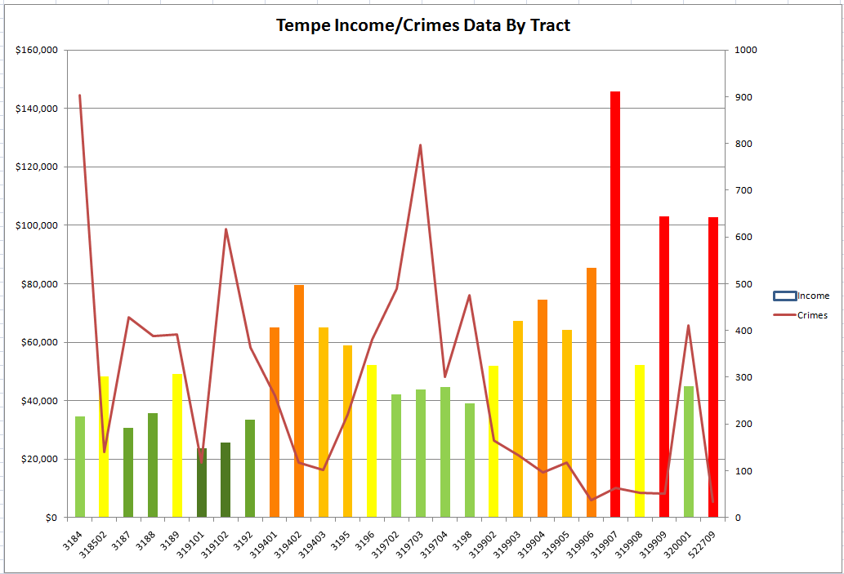
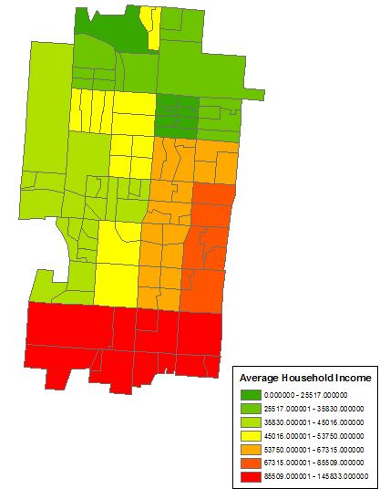
Discussion
From our results, we can see that there is a significant correlation between the average household income in a census tract and the number of crimes that occurred in the year 2010 in that given track. In the year 2010, the poverty line for a family of four in the United States was $22,050. Knowing this, we can see that there are three census tracts (319101, 319102, 3187) which fall within $10,000 of the national poverty line. Out of the total 32 census tracts, these three tracts alone accounted for approximately 13.76% of the total crime in Tempe in 2010. The correlation between income and crime rates is even further exemplified when one looks at the three highest earning tracts. Out of 32 census tracts, the three highest earning tracts (319907, 522720, 319910) accounted for only 4.85% of total Tempe crime. This means that the three lowest-earning census tracts had a crime rate that was a startling 284% higher than the rate seen in the three highest-earning tracts.
Conclusion and Future Research
The information we found through our research suggests that there may be some significant correlation between income rate in a particular area and that area’s crime rate. While this suggests that level of income has a significant effect on an area’s overall crime rate, we must still take into account the other factors that may affect crime rates. An area such as downtown Tempe may have a relatively high crime rate in comparison to its population, and as a result the average household income in that area may not appropriately reflect crime rates. Median age may also play a significant role in an areas overall crime rate. One might assume that an area filled with well-to-do retired seniors may see significantly lower crime than another nearby area filled with families in their 20s and 30s whom never completed any sort of college degree.
In the future, our research should be expanded in order to account for other factors which significantly affect crime rates. As suggested by the Federal Bureau of Investigation, crime rates are influenced by a number of factors including but not limited to racial/ethnic makeup, median age, education level, and family structure. These factors, along with overcrowding due to population, should be researched in-depth to see what effects, if any, they have on crime rates. It is our hope that in the near future there will be more in-depth studies into these factors and their effects on crime rates, as they can both assist law enforcement in concentrating their efforts on serious commonly-occurring crimes, and better inform the public of how they can protect themselves and others from falling victim to crimes.
Works Cited
Andrew Rundle, et al. "Disparities in Urban Neighborhood Conditions: Evidence from GIS Measures and Field Observation in New York City." Journal of Public Health Policy 30.(2009): S264-S285. Academic Search Premier. EBSCO. Web. 29 Apr. 2011.
Cheryl L. Addy, et al. “Socioeconomic Status and Perceptions of Access and Safety for Physical Activity.” Annals of Behavioral Medicine 28.1 (2004): 20-28. Academic Search Premier. EBSCO. Web. 29 Apr. 2011.
Glaeser, Edward L., Matt Resseger, and Kristina Tobio. "INEQUALITY IN CITIES." Journal of Regional Science 49.4 (2009): 617-646. Academic Search Premier. EBSCO. Web. 29 Apr. 2011.
Lyons-Ruth, Karlenz, and Deborah Block. "The Disturbed Caregiving System: Relations among Childhood Trauma, Maternal Caregiving, and Infant Affect and Attachment." Infant Mental Health Journal 17.3 (1996): 77-95. Academic Search Premier. EBSCO. Web. 2 May 2011.
“Tempe Today.” City of Tempe. Web. 22 Feb. 2011 <http://www.tempe.gov/tempetoday/images/ Current.pdf>.
“Variables Affecting Crime.” Federal Bureau of Investigation. Web. 22 Feb. 2011 <http://www2.fbi.gov/ ucr/cius2009/about/variables_affecting_crime.html>.

